EMResource Dialysis Center
Quick User Guide

Last Update: September 4, 2015

For Support, please contact:
Renal Network of the Upper Midwest, Inc. (ESRD Network 11)
Phone Number: 651-644-9877

STEP 1
Go To:
https://emresource.emsystem.com/login

STEP 2
Input your USERNAME and PASSWORD in the designated fields and click Log In

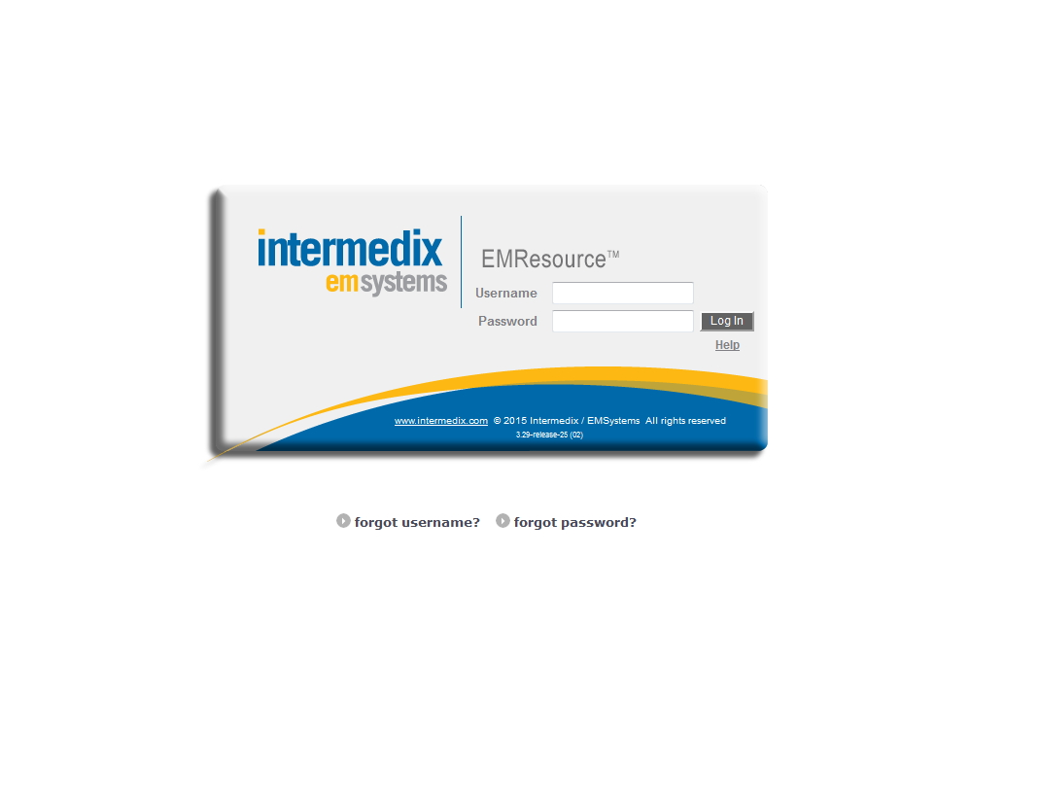

STEP 3
Click on key to access data form.

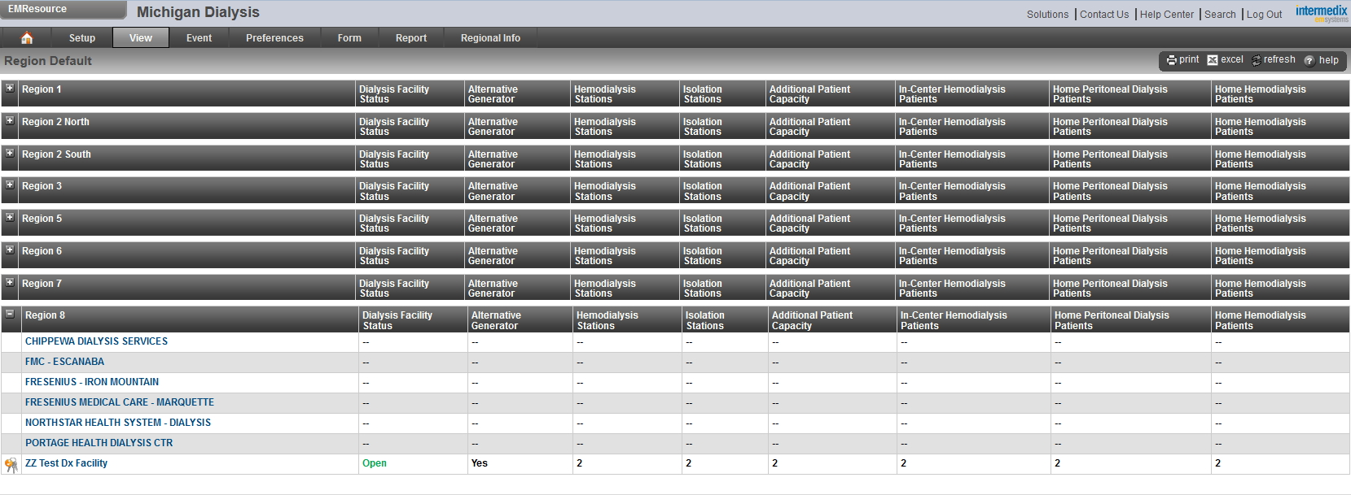

STEP 4
Update Status:
- Click on Select All, or
- Click on box to the left on the category field to input data.

To provide any additional comments, use the comment box.

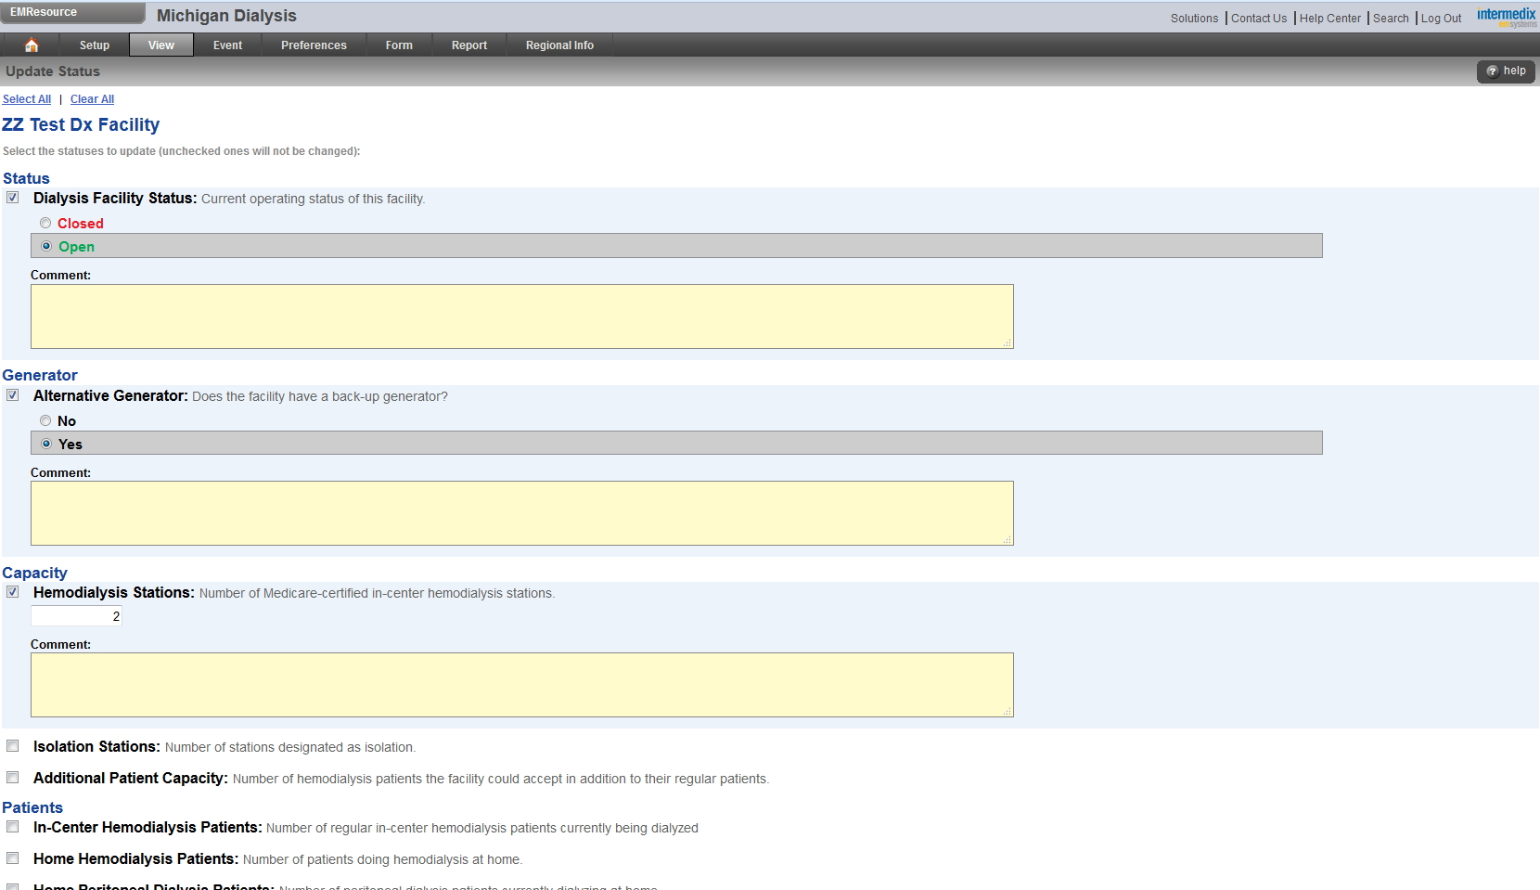

STEP 5
Click on SAVE when data input and/or comments are completed.
Failure to SAVE will not capture your information.

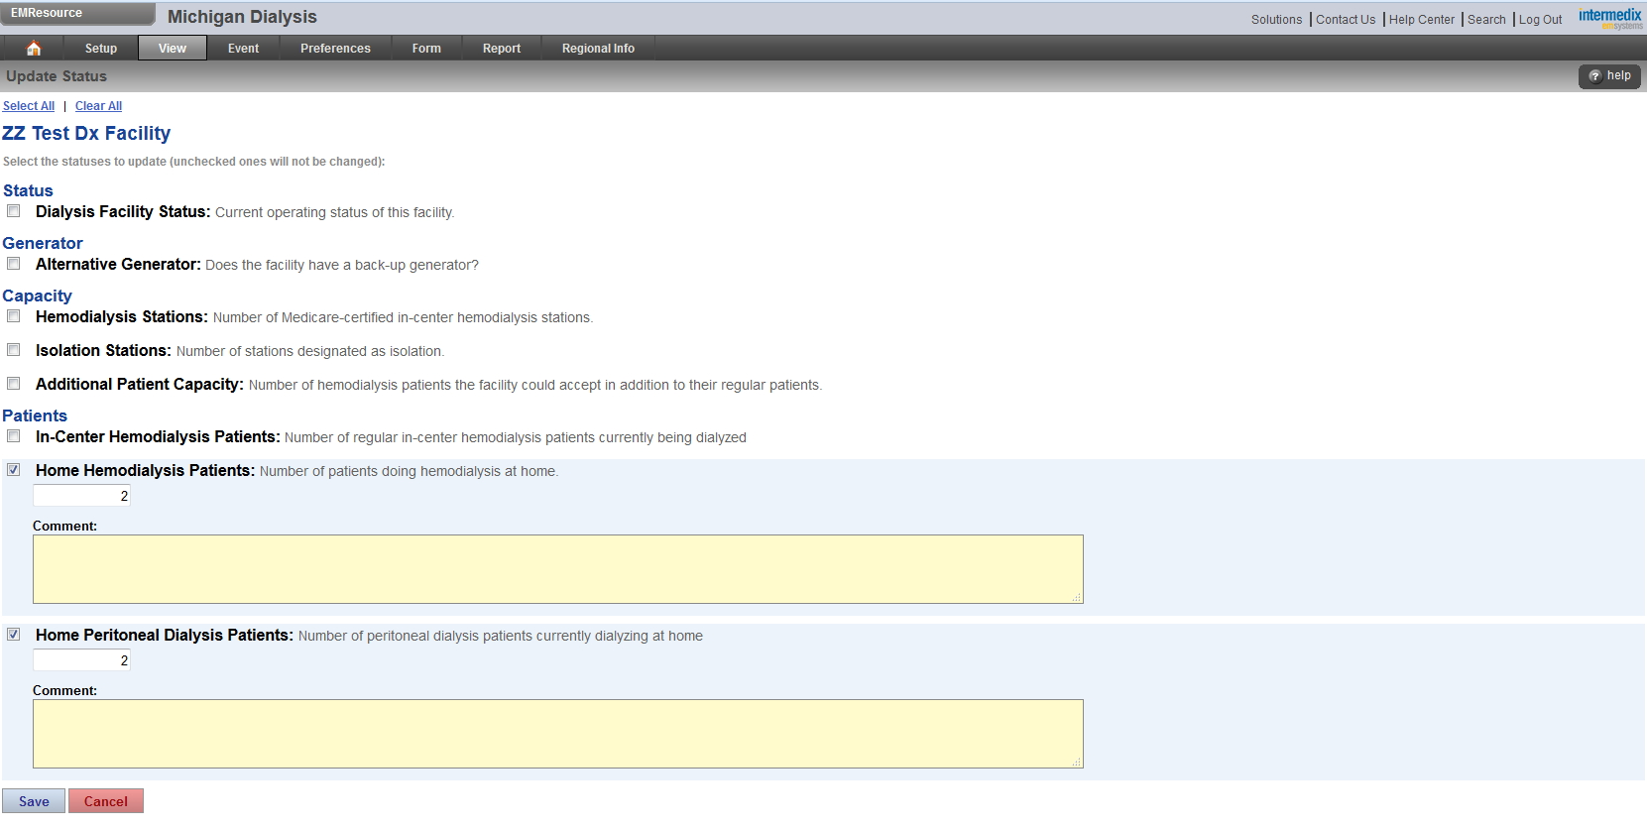

STEP 6
Verify data was saved and data input is correct.

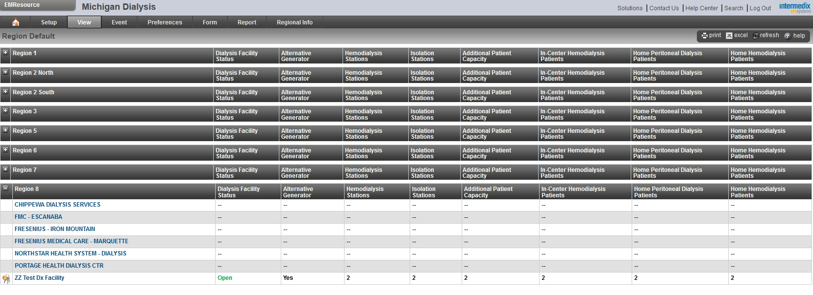

STEP 7
Select Log Out to exit EMResource.

STEP 7
Have a nice day!



Dialysis Center Categories and Descriptions

Note: If your facility does not have one or more of the below capabilities just enter “0,” do not leave field blank.

DIALYSIS FACILITY STATUS
Current status of facility as either open or closed.

ALTERNATIVE GENERATOR
Does the facility have a back-up generator?

HEMODIALYSIS STATIONS
Number of Medicare-certified in-center hemodialysis stations.

ISOLATION STATIONS
Number of stations designated as isolation.

ADDITIONAL PATIENT CAPACITY
Number of hemodialysis patients the facility could accept in addition to their regular patients.

IN-CENTER HEMODIALYSIS PATIENTS
Number of regular in-center hemodialysis patients currently being dialyzed.

HOME PERITONEAL DIALYSIS PATIENTS
Number of peritoneal dialysis patients currently dialyzing at home.

HOME HEMODIAYSIS PATIENTS
Number of patients doing hemodialysis at home.

